**CONCEPTS OF ETHICAL HACKING LAB**

**WEEK – 4**

**DOS (Denial of Service) ATTACK**

The practise of sending fraudulent communications that appear to come from a reputable source. Usually done through email. An art of psychological manipulation to deceive people into reveling sensitive information.

**Requirements:**

1.VM Ware/ Virtual Box

2.Linux

3. https://github.com/Ha3MrX/DDos-Attack

**Procedure:**

1. Install VMWare/VirtualBox and open it.
2. Install Kali Linux in the VMWare/VirtualBox and Log In.
3. Open terminal and type this command
4. git clone https://github.com/Ha3MrX/DDos-Attack
5. cd DDos-Attack
6. python2 ddos-attack,py
7. 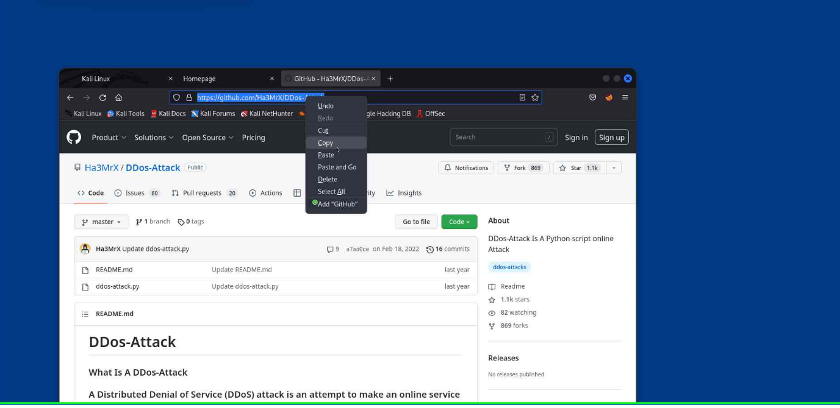
8. 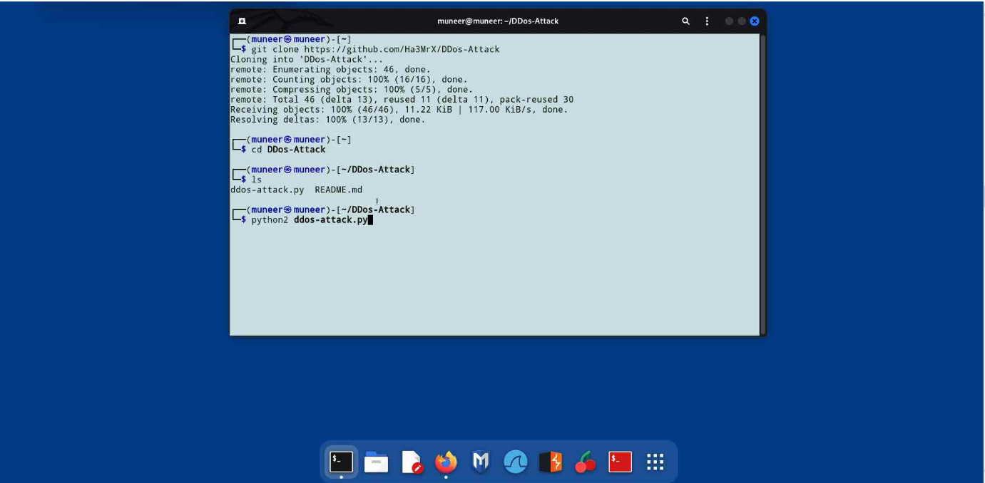
9. Select website for target
10. Example: [www.cmrphone/42web.io](http://www.cmrphone/42web.io)
11. Select the ports number for traffic
12. Example : 8080
13. 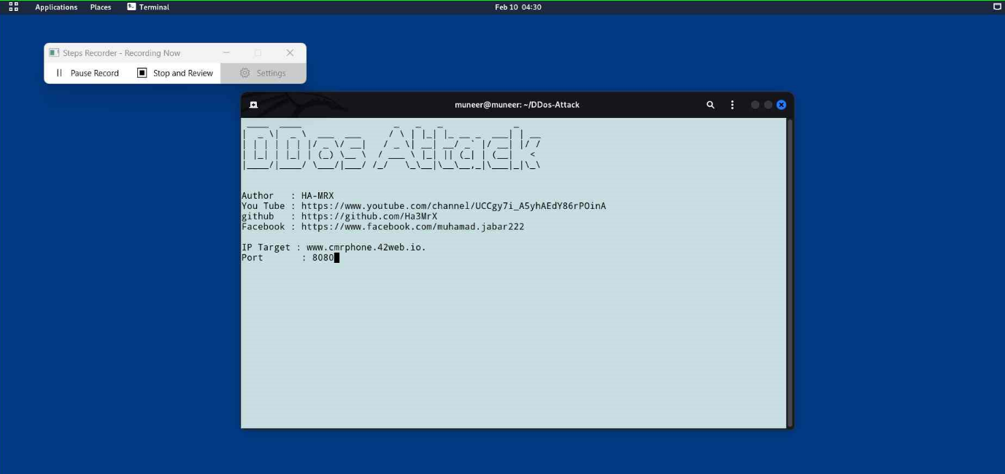
14. 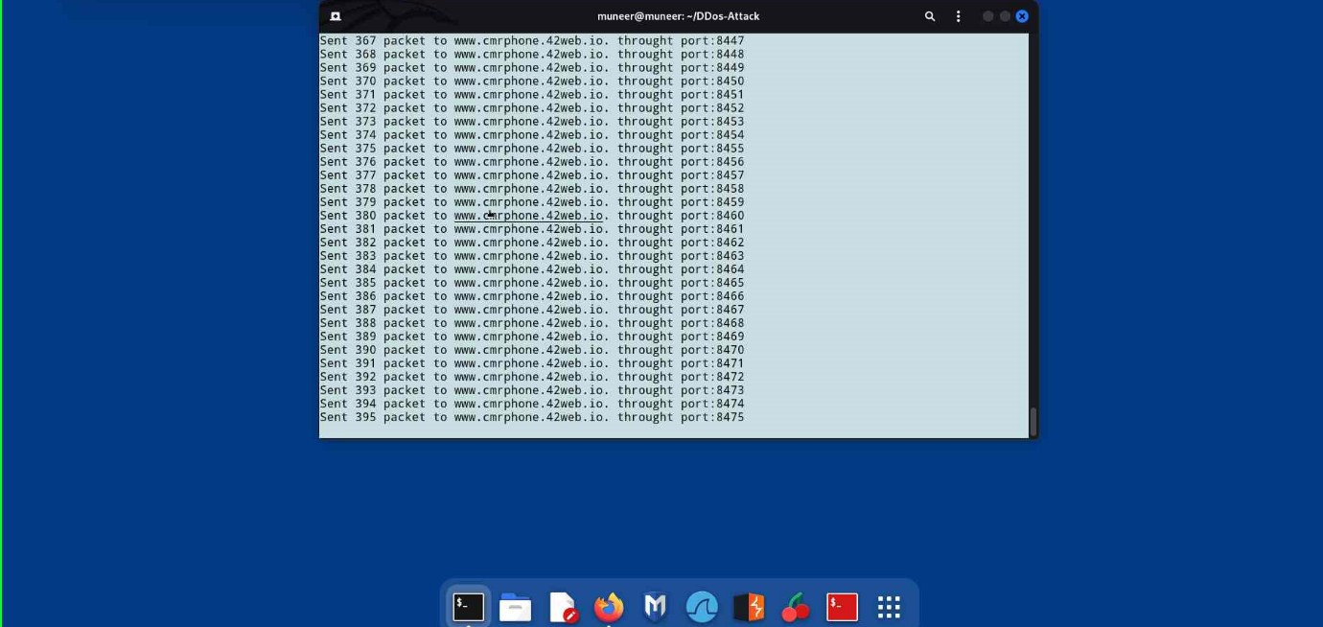
15. Cltr + c for stop the attack
16. Output:
17. 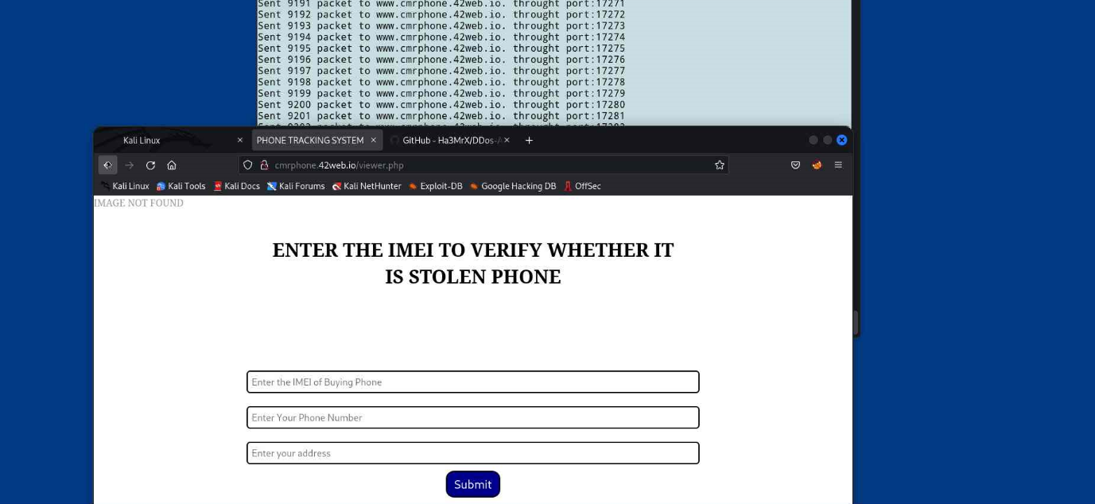

----END---